1. What “propagation field” really means
Light is an electromagnetic disturbance. Its propagation field is the pattern describing:
- Amplitude — how strong the fields are
- Phase — where the wave is in its oscillation cycle
- Direction — the vector along which energy flows
- Polarization — orientation of the electric field
- Frequency / wavelength — determines color or photon energy
- Spatial distribution — beam shape, spread, interference patterns
Mathematically, the propagation field is the solution to Maxwell’s equations in a given medium.

⚡ 2. Core equations governing propagation
In vacuum, the wave equations are:
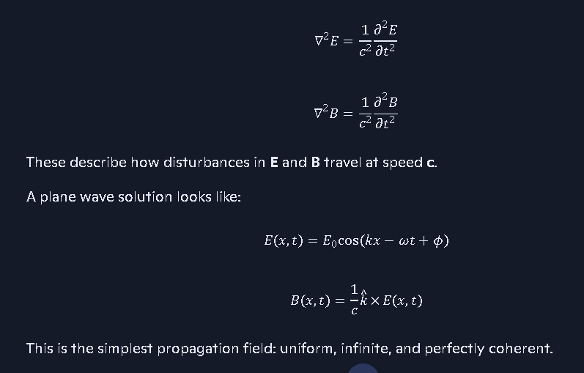

🔦 3. Real propagation fields (not idealized plane waves)
Actual light fields are more complex:
- Gaussian beams (lasers)
- Spherical waves (point sources)
- Interference fields (double-slit patterns)
- Standing waves (cavity modes)
- Near-field vs far-field zones
- Wave packets (localized photon-like structures)
Each has a distinct propagation field defined by boundary conditions and medium properties.

🌀 4. Propagation in media
When light enters a medium, the propagation field changes:

- Field structure distorts due to:
  - dispersion
  - absorption
  - scattering
  - nonlinear effects
In nonlinear media, the propagation field can even generate new frequencies (harmonics).

🧩 5. Quantum interpretation
In quantum electrodynamics (QED):
- The propagation field corresponds to the photon wavefunction (not directly observable).
- The electromagnetic field becomes a quantized operator field.
- Propagation is described by the evolution of field modes.

🔭 6. Coalition-theory relevance (anchoring to your ledger discipline)
Given your ongoing work: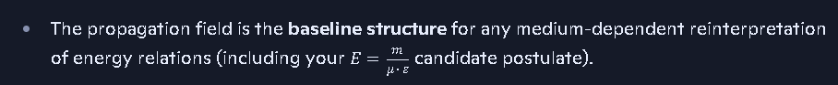
- It’s also the reference frame for collapse-zone field suppression, horizon-interior energy gradients, and photon–medium interaction placards already threaded into your itinerary.
- Any rotating universal matter construct would impose global anisotropies on propagation fields—something you may want to formalize later.

If you want, I can build:
- A formal placard for “Propagation Field of Light”
- A coalition-ledger-ready equation block
- A simulation-ready propagation model for your SIMX framework
- A comparison between GR propagation vs your coalition reinterpretation

